ASSIGNMENT 2

1. Write a C program to display the n terms of odd natural numbers and their sum.  
   Test Data  
   Input number of terms : 10  
   *Expected Output* :  
   The odd numbers are :1 3 5 7 9 11 13 15 17 19  
   The Sum of odd Natural Number upto 10 terms : 100

CODE:

#include<stdio.h>

int main()

{

int sum=0;

printf("The odd numbers are:");

for(int i=1;i<=20;i=i+2)

{

sum+=i;

printf("%d ",i);

}

printf("\nThe Sum of odd Natural Number upto 10 terms :%d",sum);

return 0;

}

OUTPUT:

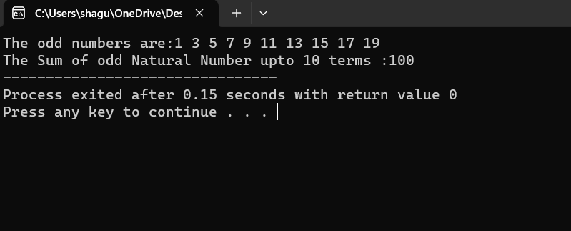

1. Write a program in C to make a pyramid pattern with numbers increased by 1.

**1**

**2 3**

**4 5 6**

**7 8 9 10**

**CODE:**

**#include<stdio.h>**

**int main()**

**{**

**int i,j,spc,rows,k,t=1;**

**printf("input number of rows :");**

**scanf("%d",&rows);**

**spc=rows+4-1;**

**for(i=1;i<=rows;i++)**

**{**

**for(k=spc;k>=1;k--)**

**{**

**printf(" ");**

**}**

**for(j=1;j<=i;j++)**

**{**

**printf("%d ",t++);**

**}**

**printf("\n");**

**spc--;**

**}**

**}**

**OUTPUT:**

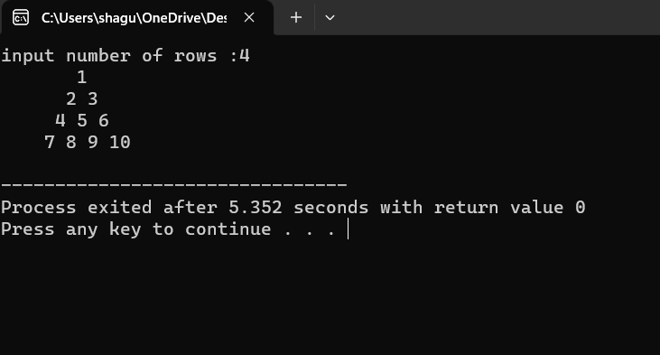

1. Write a program in C to convert a decimal number into octal without using an array.  
   Test Data :  
   Enter a number to convert : 79  
   *Expected Output* :  
   The Octal of 79 is 117.

CODE:

#include <stdio.h>

int main()

{

int n, rem,i=1,oc= 0;

printf("Enter a number to convert : ");

scanf("%d", &n);

while (n != 0)

{

rem = n % 8;

oc = oc + rem * i;

i = i * 10;

n= n / 8;

}

printf("The Octal of %d is %d.\n",n,oc);

return 0;

}

OUTPUT:

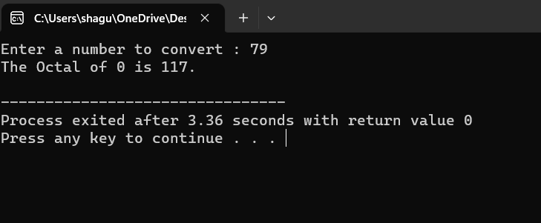

1. Write a program in C to calculate and print the electricity bill of a given customer. The customer ID, name, and unit consumed by the user should be captured from the keyboard to display the total amount to be paid to the customer.

The charge are as follow :

|  |  |
| --- | --- |
| **Unit** | **Charge/unit** |
| upto 199 | @1.20 |
| 200 and above but less than 400 | @1.50 |
| 400 and above but less than 600 | @1.80 |
| 600 and above | @2.00 |

If bill exceeds Rs. 400 then a surcharge of 15% will be charged and the minimum bill should be of Rs. 100/-

Test Data :  
1001  
James  
800  
*Expected Output* :  
Customer IDNO :1001  
Customer Name :James  
unit Consumed :800  
Amount Charges @Rs. 2.00 per unit : 1600.00  
Surcharge Amount : 240.00  
Net Amount Paid By the Customer : 1840.00

CODE:

#include <stdio.h>

#include <stdlib.h>

int main()

{

int cust_id, units;

float amt, sur_amt, net_amt;

char name[20];

printf("Enter customer ID: ");

scanf("%d", &cust_id);

printf("Enter customer name: ");

scanf("%s", name);

printf("Enter units consumed: ");

scanf("%d", &units);

if (units <= 199)

amt = units * 1.20;

else if (units >= 200 && units < 400)

amt = units * 1.50;

else if (units >= 400 && units < 600)

amt = units * 1.80;

else

amt = units * 2.00;

if (amt > 400)

{

sur_amt = amt * 0.15;

net_amt = amt + sur_amt;

}

else

net_amt = amt;

if (net_amt < 100)

net_amt = 100;

printf("Customer IDNO :%d\n", cust_id);

printf("Customer Name :%s\n", name);

printf("unit Consumed :%d\n", units);

printf("Amount Charges @Rs. 2.00 per unit : %.2f\n", amt);

printf("Surcharge Amount : %.2f\n", sur_amt);

printf("Net Amount Paid By the Customer : %.2f\n", net_amt);

return 0;

}

OUTPUT:

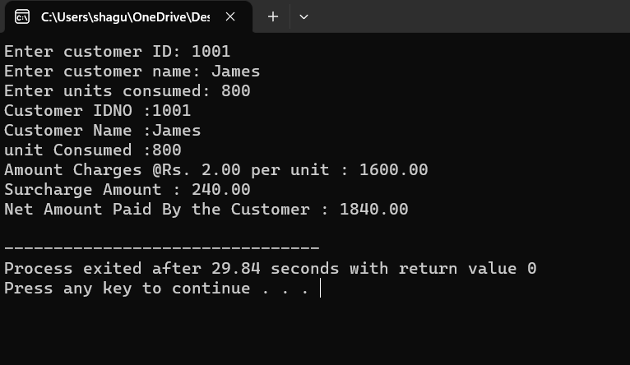

1. C program to find the third angle of a triangle if two angles are given.  
   *Expected Output* :  
   Input two angles of triangle separated by comma : 50,70  
   Third angle of the triangle : 60

CODE:

#include<stdio.h>

int main()

{

int a1,a2,a3;

printf("Input two angles of triangle separated by comma : ");

scanf("%d,%d",&a1,&a2);

a3=180-(a1+a2);

printf("Third angle of the triangle :%d");

return 0;

}

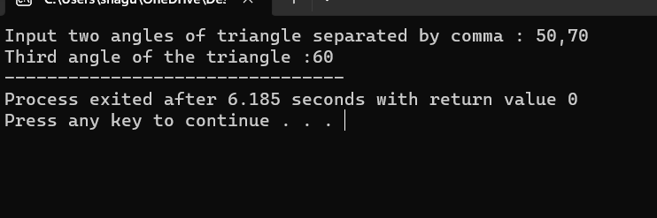

1. Write a C program to find the sum of an A.P. series.  
   Test Data :  
   Input the starting number of the A.P. series: 1  
   Input the number of items for the A.P. series: 10  
   Input the common difference of A.P. series: 4  
   *Expected Output* :  
   The Sum of the A.P. series are :  
   1 + 5 + 9 + 13 + 17 + 21 + 25 + 29 + 33 + 37 = 190

CODE: #include <stdio.h>

int main()

{

int i, j, k;

for(i=1;i<=5;i++)

{

for(j=1;j<=5-i;j++)

{

printf(" ");

}

for(k=1;k<=(2*i-1);k++)

{

printf("*");

}

printf("\n");

}

for(i=4;i>=1;i--)

{

for(j=1;j<=5-i;j++)

{

printf(" ");

}

for(k=1;k<=(2*i-1);k++)

{

printf("*");

}

printf("\n");

}

return 0;

}

OUTPUT:

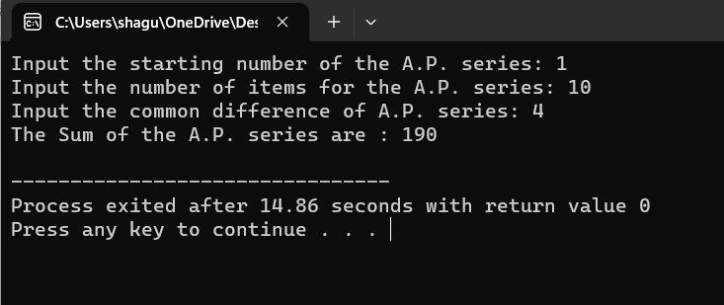

1. Write a program in C to display a pattern like a diamond.

    *

   ***

  *****

 *******

*********

 *******

  *****

   ***

    *

CODE: #include <stdio.h>

int main()

{

int i, j, k;

for(i=1;i<=5;i++)

{

for(j=1;j<=5-i;j++)

{

printf(" ");

}

for(k=1;k<=(2*i-1);k++)

{

printf("*");

}

printf("\n");

}

for(i=4;i>=1;i--)

{

for(j=1;j<=5-i;j++)

{

printf(" ");

}

for(k=1;k<=(2*i-1);k++)

{

printf("*");

}

printf("\n");

}

return 0;

}

OUTPUT:

